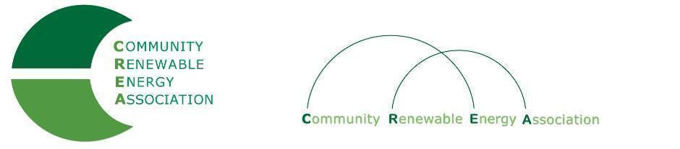

Community Renewable Energy Association
Minutes of the Executive Board

Date: September 13, 2019
Time: 10:00 am – 10 am
Location: CGCC Board Room

Meeting Cancelled.

