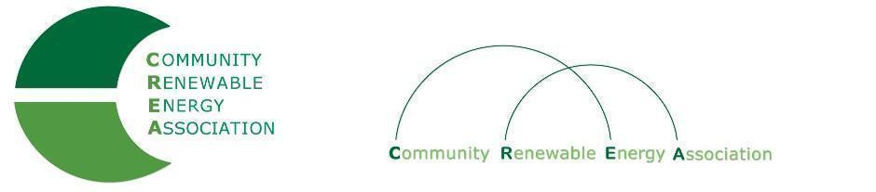
Executive Board Agenda
Friday, July 12, 2019: 10am-1:00pm
Board Room
Prineville City Hall
Prineville, Oregon
Call in #: 712.451.0979
Access Code: 689070

- Call to Order – Ormond Hilderbrand
- Roll Call/Introduction

- Open Agenda – Ormond Hilderbrand
- Time set aside for any issues not presented on the agenda

- Business Meeting – Ormond Hilderbrand
- Approval of Minutes of June 14, 2019

4. Proposed Dues Structure –Brian Skeahan

5. Public Records Request - Brian Skeahan & Rob Bovett

6. Update: Legislative - Doris Penwell, Brian Skeahan

7. Update: OPUC – Brian Skeahan

8. Update: Goldendale Pumped Storage - Brian Skeahan

9. Preparation for September strategic discussion meeting

10. Adjourn

