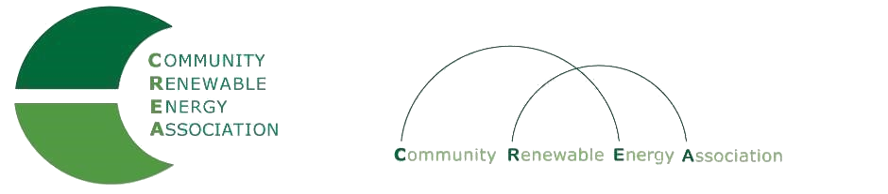
www.community-renewables.com

CREA Executive Committee Meeting
February 10, 2020
Association of Oregon Counties
1201 Court St.
Salem Or
Call in #: 712.451.0979
Access Code: 689070

1. Call to Order
– Les Perkins, CREA Chair
- Welcome and introductions

2. Open Agenda – Les Perkins
Time set aside for any issues not on the agenda

3. Business Meeting –
Approval of January 10, 2020 meeting minutes
Approval of December 2019 financial reports
Approval of January 10, 2020 financial reports

4. CREA Strategic Discussion Overview – Brian Skeahan, Executive Director

5. Strategic Planning Discussion– Brian Skeahan
Overview/Discussion of work to date
Next Steps

6. Repowering/Central Assessment Update – Brian Skeahan

7. Adjourn

