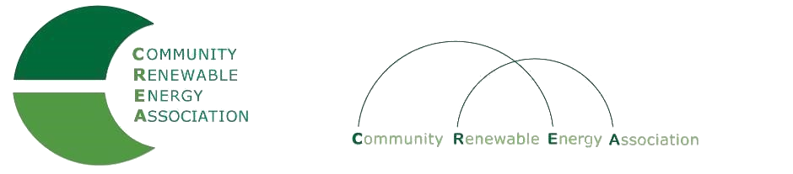
www.community-renewables.com

CREA Executive Committee Meeting
March 19, 2020
Association of Oregon Counties
1201 Court St., Room 117
Salem Or
Call in #: 712.451.0979
Access Code: 689070

1. Call to Order
– Les Perkins, CREA Chair
- Welcome and introductions

2. Open Agenda – Les Perkins
Time set aside for any issues not on the agenda

3. Business Meeting – Les Perkins
Approval of February 10, 2020 meeting minutes
Approval of January 2020 financial reports

4. Strategic Planning Discussion – Brian Skeahan
Overview/Discussion of work to date
Adopt Plan
Next Steps

6. Next meeting dates and locations– Brian Skeahan

7. Adjourn

