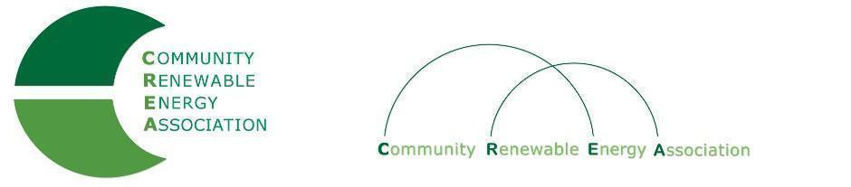
Executive Board Agenda
Friday, May 10, 2019: 10am-1:00pm
Board Room
Columbia Gorge Community College
The Dalles, Oregon
Call in #: 712.451.0979
Access Code: 689070

- Call to Order - Don Russell
- Roll Call/Introduction

- Open Agenda – Don Russell
- Time set aside for any issues not presented on the agenda

- Business Meeting - Don Russell
- Approval of Minutes of April 12, 2019
- Acceptance of Financials for April 2019

4. Report: Dues Sub-Committee –Brian Skeahan, ,Ormand Hilderbrand.Les Perkins, Elizabeth Farrar, David Brown

5. Draft: FY 2019/2020 Budget - Brian Skeahan

6. Discussion: New Member
PGE
7. Discussion: Policy for Removal of Member – David Brown

8. Update: Legislative - Doris Penwell, Brian Skeahan

9. Update: OPUC – Brian Skeahan

10. Update: Goldendale Pumped Storage - Brian Skeahan

11. Adjourn

