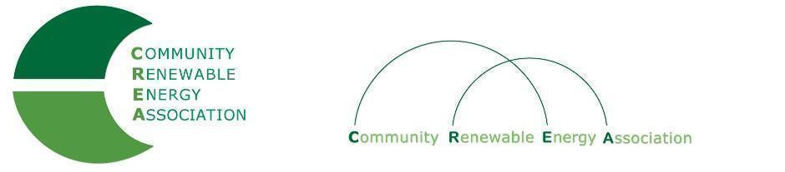
Executive Board Agenda
Friday, June 14, 2019: 10am-1:00pm
Board Room
Columbia Gorge Community College
The Dalles, Oregon
Call in #: 712.451.0979
Access Code: 689070

- Call to Order - Don Russell
- Roll Call/Introduction

- Open Agenda – Don Russell
- Time set aside for any issues not presented on the agenda

- Business Meeting - Don Russell
- Approval of Minutes of May 10, 2019
- Acceptance of Financials for May 2019

4. Proposed Dues Structure: Dues Sub-Committee –Brian Skeahan, ,Ormand Hilderbrand., Elizabeth Farrar, David Brown

5. Proposed FY 2019/2020 Budget - Brian Skeahan

6. Update: Legislative - Doris Penwell, Brian Skeahan

7. Update: OPUC – Brian Skeahan

8. Update: Goldendale Pumped Storage - Brian Skeahan

9. Adjourn

