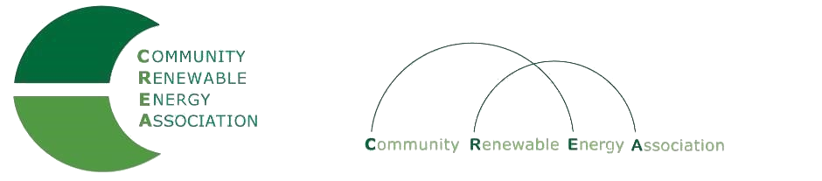
www.community-renewables.com
CREA Executive Committee Meeting
September 11, 2020,
10: 00 am – Noon
Zoom meeting
Call in #: Will distribute when received (PIN: )

1. Welcome and introductions – Les Perkins, CREA Chair

2. Open Agenda – Les Perkins
Time set aside for any issues not on the agenda

3. Business Meeting – Les Perkins
Approval of July 19, 2020 meeting minutes
Approval of July 2020 financial reports
Approval of August 2020 financial reports?

4. Audit Report – Brian Skeahan

5. Discussion related to the hiring of a new CREA Executive Director – Rob B. & Brian S
a. Discussion of hiring standards, criteria and policy directives
b. Public input related to hiring standards, criteria and policy directives
c. Deliberation and possible adoption of hiring standards, criteria and policy directives

6. Five Options for CREA’s future – Brian Skeahan

7. SIP Agreements – Brian Skeahan

8. Jake Stephens’ Bill – Brian Skeahan

9. Pump storage project – Brian Skeahan

10. Oregon Department of Revenue Meeting – Brian Skeahan

11. Next meeting dates and locations– Brian Skeahan

12. Adjourn

