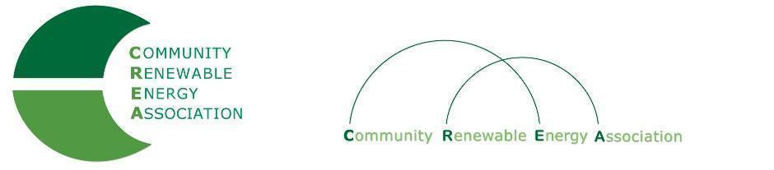

Executive Board Agenda
Friday, October 11, 2019: 10 am-11:30am
Conference call
Call in #: 712.451.0979
Access Code: 689070

1. Call to Order – Don Russell
Roll call/Introductions

2. Open Agenda – Don Russell
Time set aside for any issues not on the agenda

3. Business Meeting - Don Russell
- Approval of Minutes of August 2019
- Approval of August financial documents
-Approval of September minutes (cancelled meeting)
-Approval of September financial documents
Approve correction of November 2018 Annual Meeting minutes

4. Membership/dues update – Pat Bozanich

5. Annual meeting discussion– Brian Skeahan
- Annual meeting program
  - Hood River County Energy Plan?
  - Value of In-state renewables in context of PAC IRP?
- Nominating committee / elections

6. Set date for strategic planning session (January 2020?)

7. Adjourn

