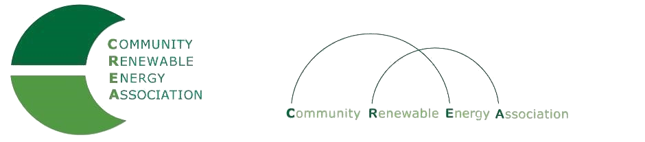
www.community-renewables.com

CREA Executive Committee Meeting
Friday, December 13, 2019, 10:00 a.m. to 11:30 am
Conference call
Call in #: 712.451.0979
Access Code: 689070

1. Call to Order
– Don Russell, CREA Chair
- Welcome and introductions

2. Open Agenda – Don Russell
Time set aside for any issues not on the agenda

3. Business Meeting – Don Russell
Approval of November 11, 2019 Annual Meeting minutes
Approval of November 2019 financial reports

4. Recap of Annual Meeting – Don Russell

5. Locations for January, February and March meetings – Brian Skeahan

6. Strategic Planning Session planning – Brian Skeahan
Set date
Agenda

7. Adjourn

