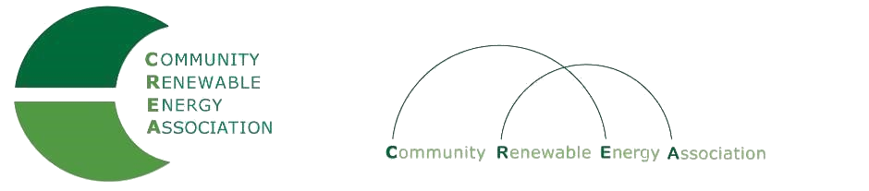
www.community-renewables.com

CREA Executive Committee Meeting
Columbia Gorge Community College
Board Room
The Dalles, Or
Call in #: 712.451.0979
Access Code: 689070

1. Call to Order
– Don Russell, CREA Chair
- Welcome and introductions

2. Open Agenda – Don Russell
Time set aside for any issues not on the agenda

3. Election of Officers for 2020 – Rob Bovett

4. Business Meeting –
Approval of December 13, 2019 meeting minutes
Approval of December 2019 financial reports

5. Strategic Planning Session planning – Brian Skeahan
Overview/Discusion
Next Steps

6. Repowering – Brian Skeahan

7. Adjourn

