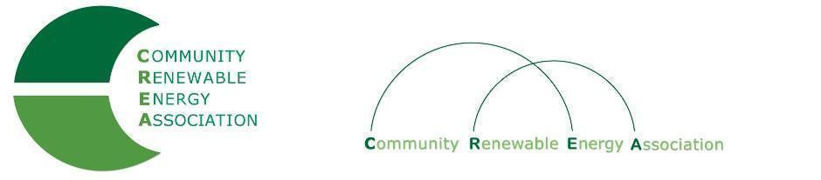
www.community-renewables.org

LINKS for Agenda Items:

#3:
County Check In:
Solar company rejects WDFW suggestions on fencing (article):
https://mail.google.com/mail/u/2/#inbox?projector=1

Dual Use Solar Executive Summary:
solar + agriculture + conservation

Review latest EFSC project list
https://www.oregon.gov/energy/facilities-safety/facilities/Documents/General/EFSC-Project-Updates.pdf?_cldee=bXdtQGNvbW11bml0eS1yZW5ld2FibGVzLm9yZw==&recipientid=contact-0f4e9fe87839eb11a813001dd8018943-ff80fc4c7222446fab6e4ff40ca038f2&esid=f926b1c0-0069-ec11-8f8e-001dd800b116

#7:
Community Renewable Energy Grant Program (ODOE):
State of Oregon: INCENTIVES - Community Renewable Energy Grant Program

Community Renewable Energy Grant Program Rulemaking
https://www.oregon.gov/energy/Get-Involved/Pages/CREP-Rulemaking.aspx

Notice Of Proposed Rulemaking re: ODOE Grant Program (State of Oregon):
https://www.oregon.gov/energy/Get-Involved/rulemakingdocs/2021-12-22-CREP-Filed-Hearing-Notice-Track-Changes.pdf

