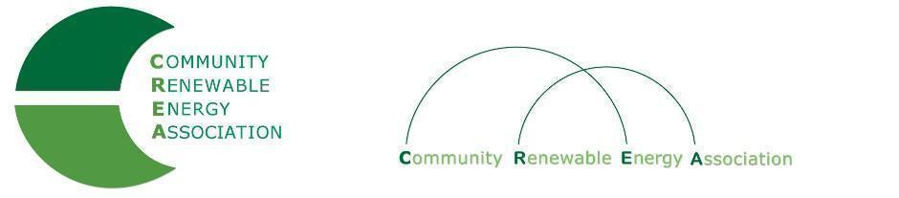
Executive Board Agenda
Friday, July 13, 2018: 10am-1:00pm
Prineville City Hall, 387 NE 3rd St. Prineville, OR 97754
Call in #: 712.451.0979
Access Code: 689070

- Call to Order – Don Coats
- Roll Call/Introductions

- Open Agenda – Don Coats
- Time set aside for any issues not presented on the agenda

- Business Meeting
- Approval of Executive Board meeting Minutes of June 8, 2018
- Acceptance of Financials for June 2018
- Financial Audit

4. Strategic Discussion at Future Meeting

5. OPUC Update - Brian Skeahan/Greg Adams
- SB 978

6. Legislative Discussion - Brian Skeahan, Doris Penwell

7. Solar Land Use / EFSC Workgroup - Brian Skeahan, Doris Penwell
- Approval of Position Paper

8. Legal Counsel - Brian Skeahan, Gary Thompson

9. Evergreen Study Update - Brian Skeahan

10. Lewis & Clark Intern Study - Brian Skeahan

11. Goldendale Energy Storage (Formerly JD Pool) Update - Brian Skeahan

12. Adjourn

