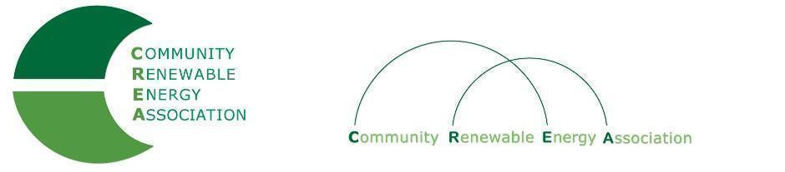
Executive Board Agenda
Friday, February 3.8.19: 10am-1:00pm
Columbia Gorge Community College
400 East Scenic Way, The Dalles, OR 97058
Call in #: 712.451.0979
Access Code: 689070

- Call to Order - Don Russell
- Roll Call/Introduction

- Open Agenda – Don Russell
- Time set aside for any issues not presented on the agenda

- Business Meeting - Don Coats
- Approval of Minutes of February 8, 2019
- Acceptance of Financials for February, 2019

4. Dues for SIP Development Members?

5. PGE Membership

6. OPUC Update - Brian Skeahan

7. Legislative Update - Doris Penwell, Jim Gardner

8. Goldendale Pumped Storage Project Update - Brian Skeahan

9. Adjourn

