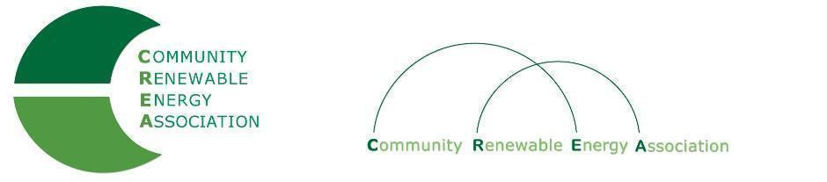
Executive Board Agenda
Friday, January 11, 2019: 10am-1:00pm
Phone Conference
Call in #: 712.451.0979
Access Code: 689070

- Call to Order – Don Russell
- Roll Call/Introductions
- Introduction: Interim Secretary, Marsha Morrison

- Open Agenda – Don Russell
- Time set aside for any issues not presented on the agenda

- Business Meeting - Don Russell
- Approval of Minutes of December 14, 2018
- Acceptance of Financials for December, 2018
- Contract with AOC re: Rob Bovett Legal Services
- Executive Board Alternates: Discussion

4. Legislative Update - Doris Penwell, Jim Gardner

5. OPUC - Greg Adams

6. PGE: CREA Membership - Brendan McCarthy

7. Goldendale Pumped Storage Update - Brian Skeahan

8. Adjourn

